16-665: Robot Mobility – Air Mobility Project
Due Nov 3 2020
David Wong (Andrew ID: DBWONG)
________________________________________________________________

1. System Diagram [20]
Figure 1: MATLAB software pipeline
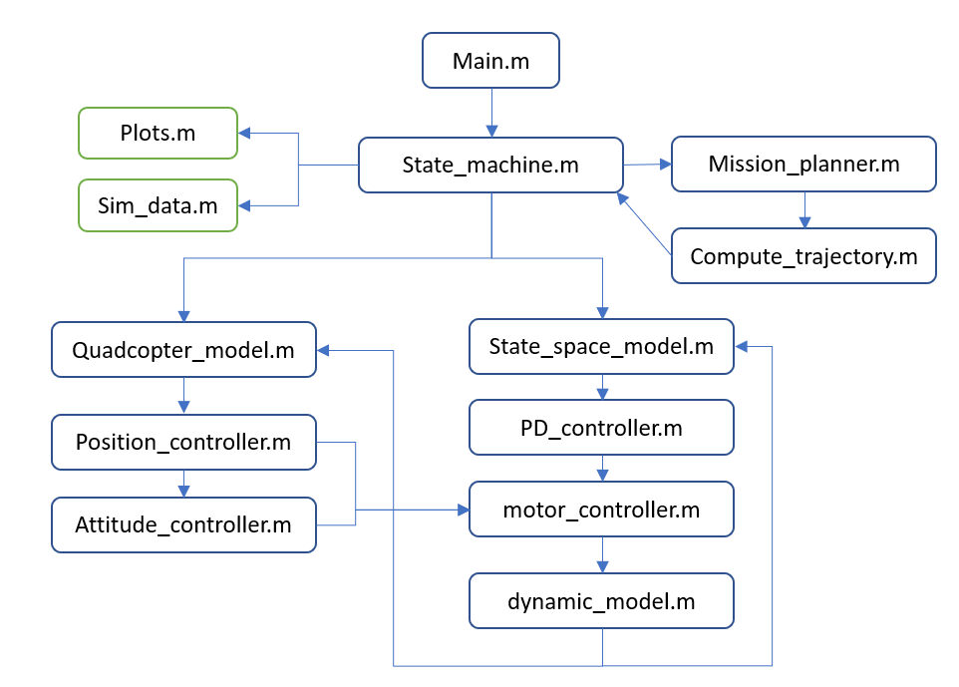
Figure 2: Quadcopter Control Architecture System Diagram
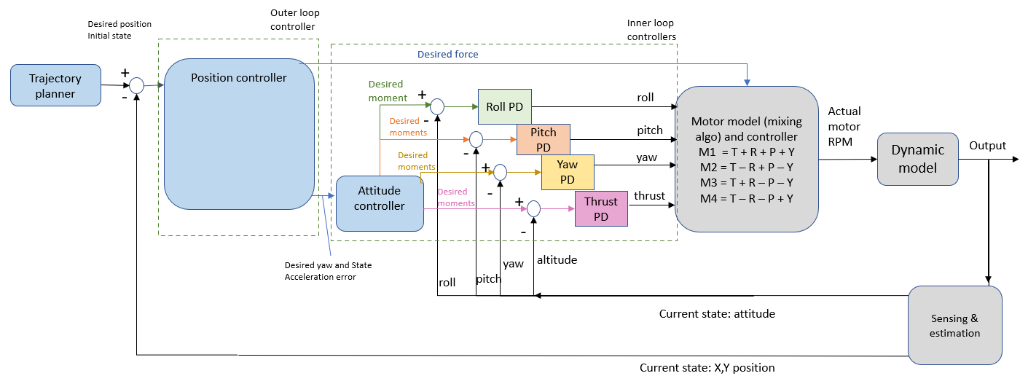
The software pipeline in Figure 1 starts with the main.m which calls on the state machine (state_machine.m) upon assignment of a mission. The mission planner determines a set of trajectories for the phases of takeoff, hover, tracking and landing with associated gains to execute each trajectory. Next, compute_trajectory.m computes the required trajectories for the state machine.
The state machine executes the required trajectories with the linearized quadcopter PD model and the state space model. The quadcopter mode (quadcopter_model.m) invokes the outer loop controller (position_controller.m) with the current state and desired position to compute the desired force and acceleration error. Vide Figure 2, the inner loop (attitude_controller.m) computes the desired moments about each axes while considering the current states of row, pitch, yaw and thrust. The motor controller (motor_controller.m) computes the required motor RPMs with the motor model – comprised of motor mixing matrix and applied the motor constant - and outputs the actual RPM to the dynamic model. This data is sent to the dynamic model (dynamic_model.m) that determines the actual forces and moments, while updating the current states - position and attitude - which is then used for closed loop control in the next iteration.
Upon execution of all the trajectories by the state machine (state_machine.m), the loop is complete and the quadcopter returns to an idle state. The software pipeline concludes with required graphs are plotted (plots.m) showing the desired and actual states for the tracking mode. Simulation data is stored in .csv format by sim_data.m.
______________________________________________________________________
2. Hover performance [20]
Use linearized feedback control policy to implement at PD feedback controller to enable hovering at desired location (e.g. z = 0.5m). Create simulation scenario where robot transitions between multiple waypoints along x-axis by specifying goals that increment by 10cm in x-direction. Plot error between desired pose (position and orientation) and the actual pose. Indicate when new waypoints are sent to the system.

Examine convergence of the robot to each waypoint. Does system oscillate about waypoint? What happens when modifying gains associated with position control (outer loop) and attitude control (inner loop)? Plot response for an additional set of gains and discuss qualitatively the change in performance.

3. Line tracking Performance [20]
Develop PD line-tracking controller to enable robot to take-off from starting location, go to fixed height of 1.0m, and return to ground. Many approaches could be used (select your preferred approach). Most naieve solution would be follow a method similar to approach detailed in (2), but reduce the magnitude of the incremental change in waypoint by a smaller value (e.g 1cm) and assign a desired velocity to each waypoint following a velocity profile (consider ramp profile due to a constant prositive, zero, then negative acceleration). Plot error betw. Desired pose (position and orientation) and actual pose.
Examine convergence of the robot to eacy waypoint. Does system oscillate about waypoint? What happens when modifying gains associated with position control (outer loop) and attitude control (inner loop)? Plot response for an additional set of gains and discuss qualitatively the change in performance.

4. State Machines [20]
Develop and detail a state machine that enables platform to takeoff to a pre-specified height, hover and track trajectories, and land. Provide description of state machine with an associated state machine diagram. One possible strategy is to develop a finite sequence of modes that transition based on current and desired states as well as the prior mode. Consider the following possible approach:
- System begins in an idle state generating no (or null) control inputs
- Simulation trial begins by transitioning into takeoff state that consists of a trajectory tracking controller from the current robot state to a desired hover state (fixed pose). When robot approaches the desired hover state (based on error between current and desired pose), the robot transits into hover mode
- Platform remains in hover mode for a small amount of time (e.g. 5s) before transitioning into a tracking mode.
- Platform tracks specified trajectory and upon completion transitions into hover mode.
- After remaining in hover mode for a brief period of time, the robot transitions into land mode and begins descent onto ground.
Remark: The above state machine is a prerequisite for remainder of exercises in this project, and provides a simple strategy for trial initialization and finalization. The following exercises will leverage this capability and assume the system is operating in tracking mode. Any requested error plots should apply only to this mode (and not include the takeoff, hover and landing phases) unless explicitly requested.

5. Goal selection and tuning [20]:
After commanding robot to takeoff and hover, generate a command that tracks a single waypoint at [0, 0 ,0.1]m (zero velocity). Plot error response of the system with respect to the desired position, orientation, linear and angular velocity. What are the rise (90%) and settling (10% times associated with the position and linear velocities? What is the steady-state value? What is the maximum percent overshoot? Now provide a waypoint at the same position but with a heading of 15deg. What are the similar time domain performance characteristics of the heading controller? How do these values (position and heading) change given different gain values?
Remark: Ensure that the values remain realistic for the actual robots (assuming a thrust-to-mass ratio of 2.6).
Description | Unit | Value
Mass | kg | 0.77
Gravity | m/s² | 9.80665
Arm length | m | 0.1103
Motor spread angle | Rad | 0.925
Thrust coefficient | N/rpm² | 8.07E-09
Moment scale | Nm/rpm2 | 1.3719E-10
Motor time constant | s⁻¹ | 36.5
Min RPM | rpm | 3000
Max RPM | rpm | 20,000
Inertia Diagonal | Kgm² | [0.0033, 0.0033, 0.005]
CoM vertical offset | m | 0.05

